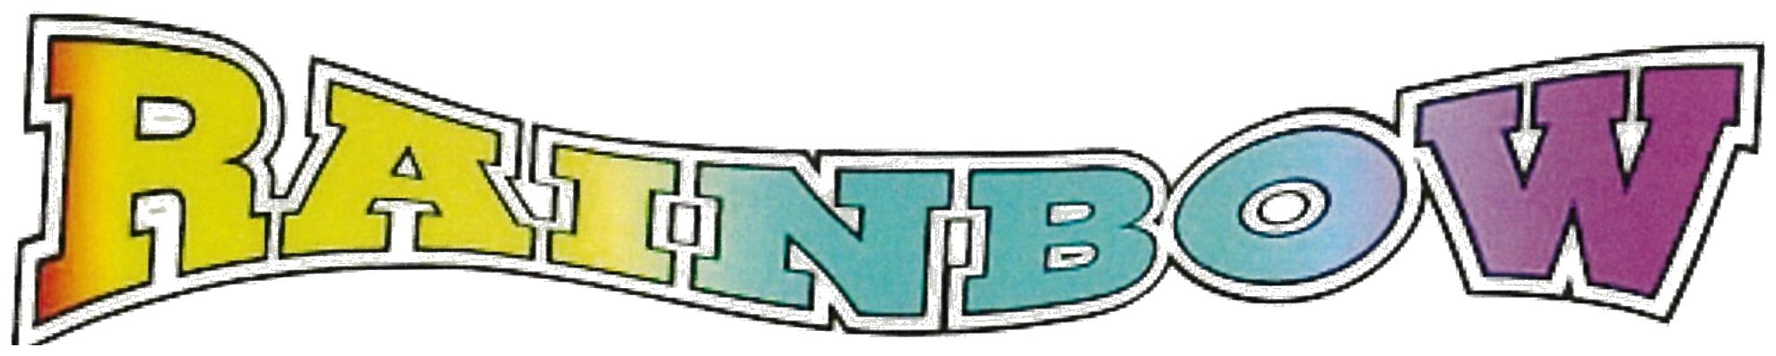
PRINTING & OFFICE SUPPLY
(775) 831-2276 • FAX (775) 831-5535
917 TAHOE BLVD., SUITE 103 • BOX 5488 • INCLINE VILLAGE, NV 89451
Prices for Printing
Business Cards U.S Sizes
3.5” x 2” or 2” x 3.5” Any other size requires a special quote.

Business Cards  Printed 1 or 2 sides on 14pt. or 16pt.  Gloss or Matte Cover or 14pt. Uncoated  These take approx. 1 week for production  Artwork can be 1 up on a page with  crop marks and bleeds | Quantity | Price
 | 100 | $49.99
 | 250 | $59.99
 | 500 | $89.99
 | 1000 | $99.99
Prices do not include Artwork and Layout Charges. • Customer can supply artwork.
Most products take approx. 1 week for production. • E-mail the file to: RainbowIncline@gmail.com
The best File format is a High Resolution pdf. with crop marks and bleeds.

Business Cards  Printed “In House” Standard U.S. Size  On 80# Cover Weight On  any 80# We have in stock  (2 Sided is not recommended)  Based on Artwork set-up 10 on a page  with crop marks and bleeds  For bleeds, set up is 8 up on a page  Yielding 20% Less quantity and  $5.00 extra for cutting. | Quantity | Price 1 sided | 2 sided
 | 100 | $34.40 | $47.30
 | 200 | $46.30 | $58.10
 | 250 | $52.25 | $67.00
 | 500 | $82.00 | $99.00
Prices do not include Artwork and Layout Charges. • Customer can supply artwork.
Cards can be either same day or 1 day for production. • E-mail the file to: RainbowIncline@gmail.com
The best File format is a High Resolution pdf. • 8 or 10 up on a page, with crop marks and bleeds.

